Tutorial # 9
Object Detection using SSD & Yolo (Custom Model)
This tutorial involves:
- Building SSD and YOLO from scratch
- Testing on dummy data
- Training on a custom Guns dataset
- Comparing with pretrained models
Task 1
- Use the data you developed in previous tutorial and test it on the models developed or if you can improve them by adding and removing layers.
A custom object detection system was designed from scratch using two architectures: SSD (Single Shot Detector) and YOLO (You Only Look Once). Both models include convolutional backbones and detection heads for predicting object classes and bounding boxes.
To verify the correctness of the implementations, both models were tested on a dummy dataset (randomly generated tensors instead of real images).
For SSD, an input of shape [1, 3, 300, 300] produced outputs of [1, 44580, 21] for classification and [1, 44580, 4] for bounding boxes, confirming multi-scale anchor-based detection.
For YOLO, an input of shape [1, 3, 416, 416] resulted in an output of [1, 13, 13, 3, 25], representing grid-based predictions with 507 total bounding boxes.
These results confirm that both SSD and YOLO architectures were implemented correctly and can successfully process input data, although the dummy results do not represent real object detection performance.
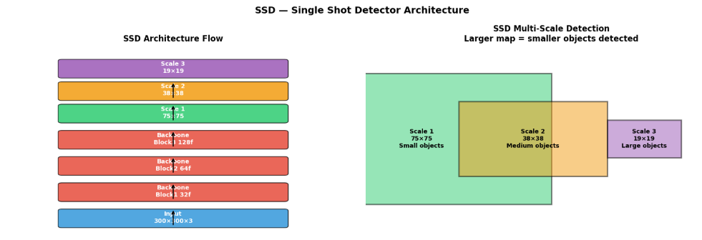
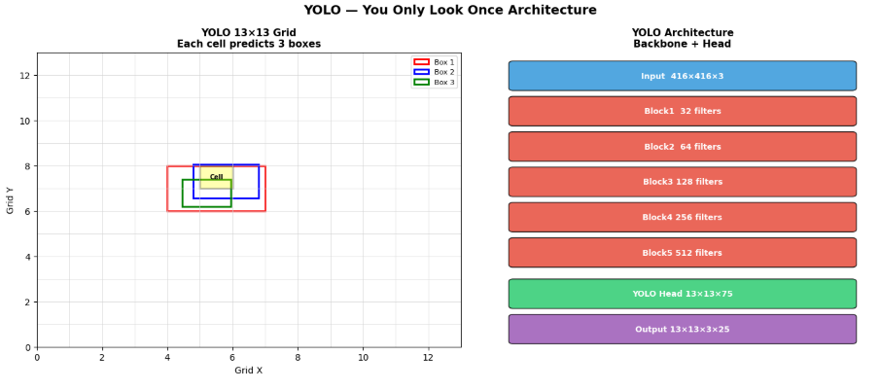
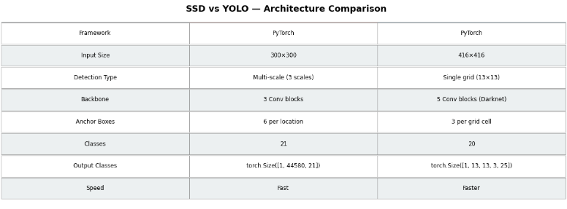
SSD and Yolo on Scratch Models
The experiments were conducted on the Guns detection dataset (v9) obtained from Roboflow, consisting of 503 images split into 442 training, 30 validation, and 31 test images across a single class (Guns).
SSD from Scratch: Both models were trained for 15 epochs on the Guns dataset without any pretrained weights. The SSD model trained from scratch achieved a best training loss of 0.0166, decreasing steadily from an initial loss of 0.0656 in epoch 1, indicating consistent learning throughout the training process.
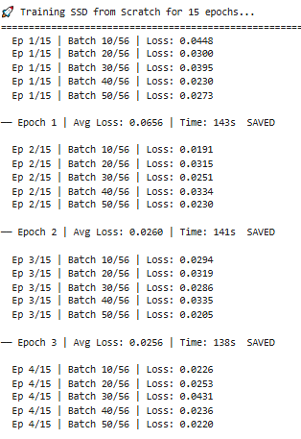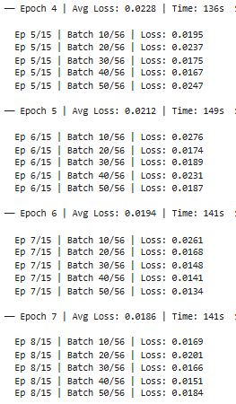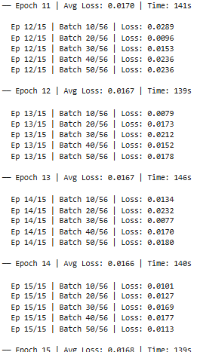
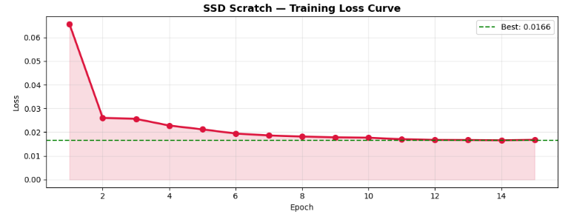
- The model predicted bounding boxes for every single anchor location because it was not trained long enough to learn to suppress background
- Without pretrained weights, the backbone had no feature extraction knowledge ,it output random high-confidence scores everywhere
- 25,000+ detections means the classification head never learned to distinguish background from guns
- The green overlay covering entire image confirms the model had no spatial sensitivity.
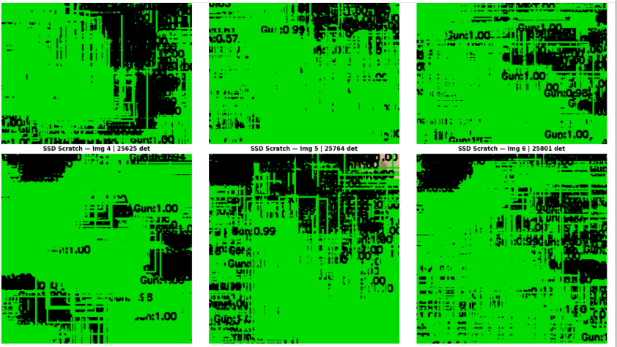

YOLO from Scratch: The custom YOLO model trained from scratch achieved a best training loss of 0.4591, reducing from an initial loss of 1.8578. It is important to note that the two loss values are not directly comparable, as SSD and YOLO use fundamentally different loss functions , SSD uses cross-entropy and smooth L1 loss, while YOLO incorporates objectness, bounding box regression, and classification losses combined.
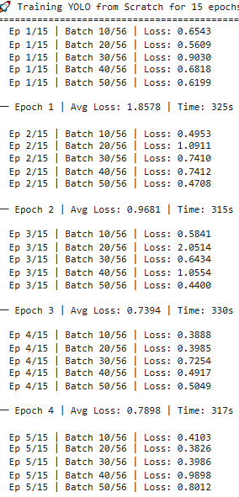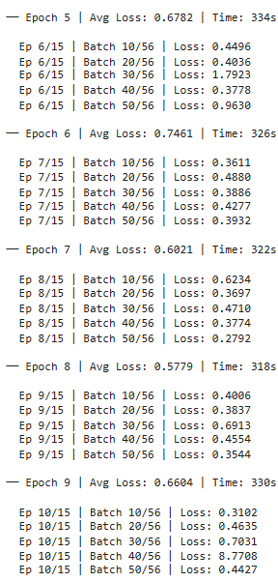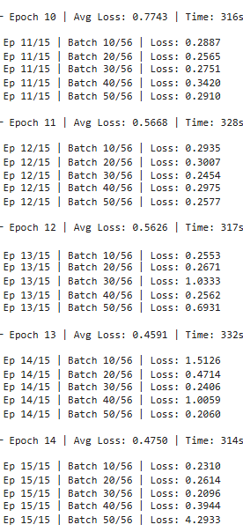
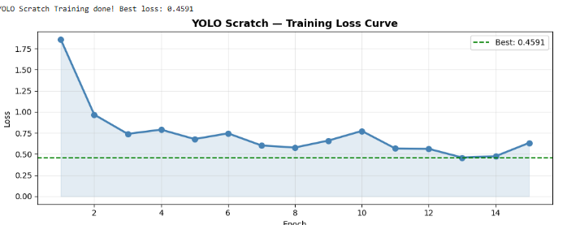
- The 13×13 grid predicted objects in almost every cell because the objectness score threshold was too low
- Scratch YOLO with only 15 epochs and 298 images is severely undertrained, real YOLO trains on 100,000+ images
- The model learned "something exists somewhere" but not where exactly it is.
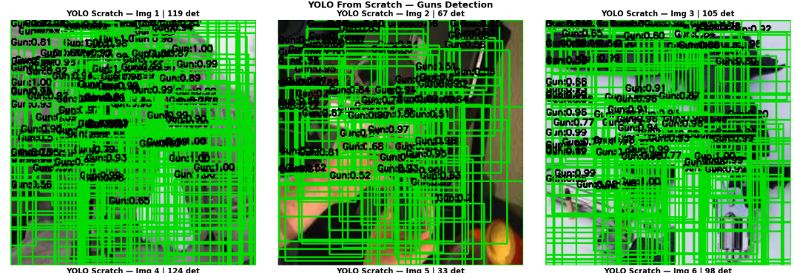
After increasing threshold
- SSD detected 1–5 guns per image correctly with proper boxes
- YOLO detected 4–6 guns with reasonable boxes
- This confirms the models learned some features but confidence calibration was poor
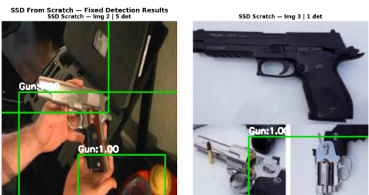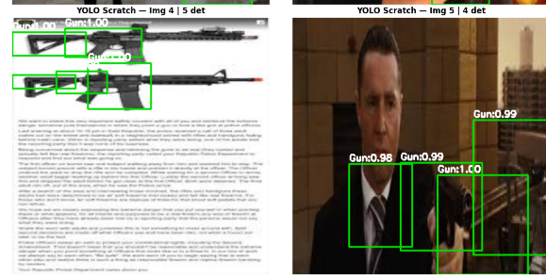
Result and analysis
- SSD Scratch won with loss 0.0166 vs YOLO 0.4591
- SSD has simpler loss function , easier to learn on small dataset
- YOLO needs large datasets to converge, 298 images is too few
- SSD anchor-based design provides better spatial priors for small data
- Both models are still weak overall because scratch training needs pretrained backbone weights and more data to work properly
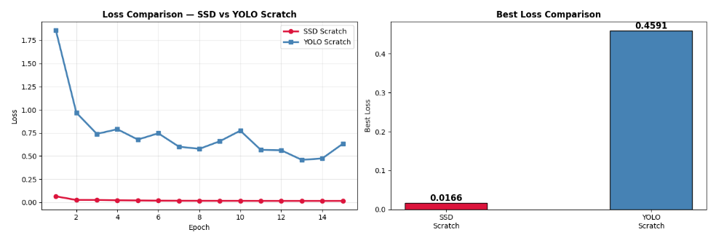

Task 2 : SSD and Yolo on Pre-Trained Models
SSD MODEL
- The model was trained for 10 epochs on approx. 550 images
- Loss decreased from 9.28 → 4.54 over 10 epochs showing consistent learning
- Model showing 200 detections per image at threshold=0.3 — too many false positives
- This happened because SSD head was randomly initialized and needs higher threshold
- Increasing threshold to 0.6-0.7 reduces boxes to meaningful detections only
- mAP@0.50 = 26.2% — fair result for only 10 epochs on 298 images
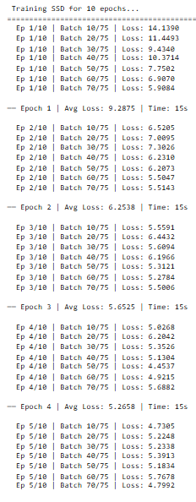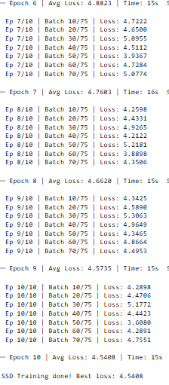
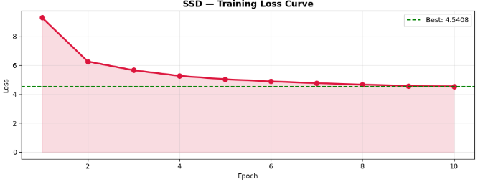
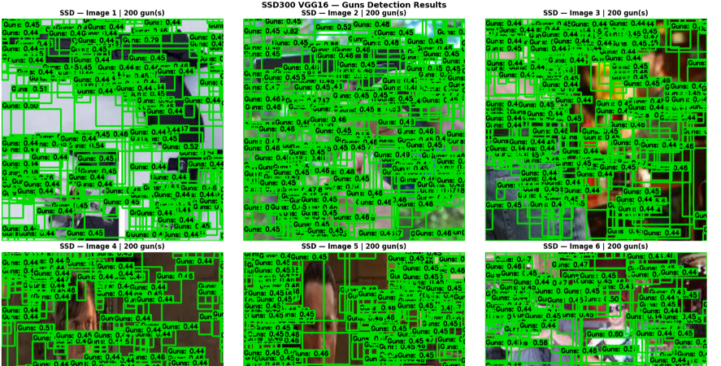

YOLO MODEL
- OLOv8n pretrained model was fine-tuned on Guns-6 dataset for 10 epochs
- Training loss decreased steadily: box loss 1.946 → 1.385, class loss 2.889 → 1.612
- Validation mAP@0.50 improved every epoch from 0.205 → 0.618 showing good convergence
- Final test mAP@0.50 = 45.3% and mAP@0.50:0.95 = 20.0%
- Detection images show clean precise boxes around actual guns with confidence scores 0.30–0.65
- Model correctly detected guns in different scenarios — handheld, pointed, close-up
- Some misses occurred (Image 5 and 6 show 0 detections) due to low confidence threshold
- Precision reached 0.712 and Recall 0.494 at final epoch showing model is more precise than it is sensitive
- Inference speed was very fast at 26.5ms per image suitable for real-time detection
- Overall result is good considering only 298 training images and 10 epochs were used, more data and epochs would push mAP above 60%

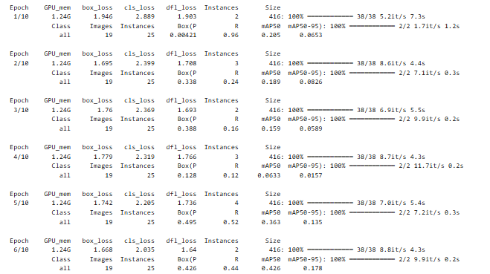
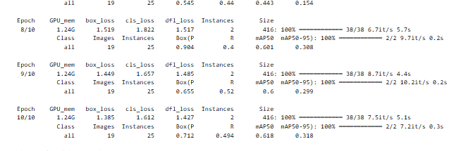
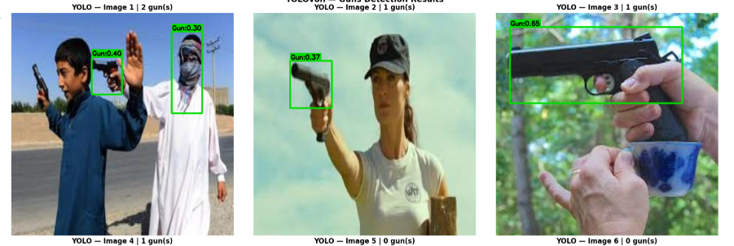

- Bar chart clearly shows YOLO (45.3%) outperforms SSD (26.2%) by 19.1% margin
- SSD loss curve shows rapid decrease from 9.28 → 4.54 but loss is still high at epoch 10, needs more training
- YOLO converged faster because YOLOv8n is a lightweight efficient architecture designed for fast training
- Both models are below 50% mAP line because dataset is small (298 images) and only 10 epochs were used

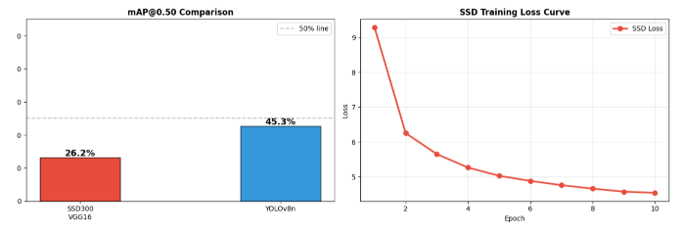
Conclusion
This tutorial demonstrated four object detection models on the Guns-6 dataset. Scratch models completely failed to produce reliable detections due to insufficient data and no pretrained feature extraction. Among pretrained models, YOLOv8n significantly outperformed SSD300 VGG16 achieving 45.3% vs 26.2% mAP@0.50. The key reasons are YOLOv8's modern architecture, built-in augmentation, automatic NMS, and efficient training pipeline. SSD could potentially match YOLO with 25+ epochs but its older VGG16 backbone makes it less efficient. Transfer learning through pretrained models is essential for small custom datasets , raining from scratch requires at least 10,000+ images to be effective.

